


Restaurant Recommendation System

Prepared For

Smart-Internz
Applied Data Science Guided project

By

Prathmesh Arvind Kumbhar
D Y Patil Agriculture and Technical University Talsande

On

11 June 2025

Abstract
This project develops a personalized restaurant recommendation system based on user preferences, location, and dining history. It analyzes factors such as cuisine, price, and ratings to suggest suitable dining options. Machine learning techniques like collaborative and content-based filtering are used for accurate suggestions. The system enhances the dining experience by offering relevant and location- aware recommendations

Final Project Report

Contents

Introduction
  - Project Overviews
  - Objectives

Project Initialization and Planning Phase
  - Define Problem Statement
  - Project Proposal (Proposed Solution)
  - Initial Project Planning

Data Collection and Preprocessing Phase
  - Data Collection Plan and Raw Data Sources Identified
  - Data Quality Report
  - Data Preprocessing

Model Development Phase
  - Model Selection Report
  - Initial Model Training Code, Model Validation and Evaluation Report

Model Optimization and Tuning Phase
  - Tuning Documentation
  - Final Model Selection Justification

Results
  - Output Screenshots

Advantages & Disadvantages
Advantages Disadvantages

Conclusion
- Future Scope
- Appendix
  - Source Code
  - GitHub & Project Video Demo Link

1 Introduction

Project overviews
The Restaurant Recommendation System is a smart, data-driven solution designed to help users efficiently discover restaurants that align with their unique preferences and situational contexts. As urbanization and mobile technologies continue to reshape consumer behavior, users are often overwhelmed by the sheer volume of available dining choices across platforms such as Google, Yelp, and Zomato. This leads to decision fatigue and suboptimal dining experiences. To solve this, the proposed system leverages a hybrid recommendation model combining collaborative filtering,
content-based filtering, and geolocation-aware services.The collaborative filtering component analyzes historical user behavior, including past restaurant visits, ratings, and interaction patterns, to identify users with similar tastes and recommend restaurants favored by like-minded individuals.
Meanwhile, the content-based filtering module evaluates restaurant attributes—such as cuisine type, price range, ambiance, and dietary offerings—to match them with explicit user preferences.
To enhance practicality, geolocation data is integrated using GPS APIs or IP-based location tracking. This allows the system to dynamically adapt its recommendations based on the user's current position or a specified location, ensuring that results are both relevant and accessible. For example, a user seeking budget-friendly vegan food in a new city would receive highly localized and personalized recommendations.
Furthermore, the system is designed with adaptive learning capabilities. Using techniques like reinforcement learning or preference feedback loops, the recommendation engine improves over time by understanding user behavior patterns, modifying weightage of features, and incorporating real-time feedback such as likes, bookmarks, or direct reviews.

1.2Objectives

    - To design and implement a recommendation engine that effectively filters and ranks restaurants based on individual user preferences, including food type, cost, ambiance, and dietary needs.
    - To apply machine learning models, such as collaborative filtering (user-based and item-based) and content-based filtering, to identify patterns in user behavior and restaurant attributes.
    - To incorporate location-aware features using GPS or user-inputted location data, ensuring that recommended restaurants are conveniently accessible to the user.
    - To gather and analyze restaurant reviews and ratings from public sources (e.g., Yelp, Google Reviews, or internal datasets) to improve the trustworthiness and relevance of suggestions.
    - To create a user-friendly interface that allows users to input preferences, view recommended restaurants, and interact with the system seamlessly.
    - To develop a feedback mechanism that collects user satisfaction data post-visit to refine future recommendations and enhance personalization over time.
    - To ensure scalability and adaptability of the system for use in different geographic regions or for integration into existing food delivery or travel applications.

2 Project Initialization and Planning Phase

Define Problem Statement
Project Initialization and Planning Phase

Date | 30 May 2025
Student Name | ***put your name
Project Name | Restaurant Recommendation system
Maximum Marks | 3 Marks

Problem Statements (Restaurant Recommendation system):

PS  No. | I am (Customer) | I’m trying to | But | Because | Which makes me feel
PS- 1 | A tourist in a new city | Find good local restaurants | I don’t know the area well | I lack local  knowledge or reviews | Confused and unsure of where to eat
PS- 2 | A vegetarian diner | Get recommendations for veg-only restaurants | Most apps show mixed cuisine places | I want strict dietary options | Frustrated and unsupported
PS- 3 | A restaurant owner | Attract more customers through recommendation platforms | My restaurant is not being recommended often | The system doesn’t promote new or small businesses | Invisible and discouraged

PS- 4 | A student on a tight budget | Find affordable but tasty restaurants | Expensive options are shown first | Filters don’t prioritize price or value | Overwhelmed and discouraged
PS- 5 | A delivery app user | Get suggestions based on past orders | It doesn't adapt to my taste | The system lacks learning | Frustrated by repetition
PS- 6 | A parent of young kids | Find kid-friendly and hygienic restaurants | No way to filter for child-friendly | Lack of safety and family-focused features amenities | Anxious about experience
PS- 7 | A small restaurant owner | Increase customer footfall via platforms | My business is buried under chain listings | Ranking algorithms favor large brands | Discouraged and invisibleguide

PS- 8 | A new-in-town resident | Explore culturally diverse food options | Unaware of hidden gems in my area | No cultural/ethnic tags or user reviews | Disconnected and bored of same cuisine
PS- 9 | A food delivery platform analyst | Monitor food safety and restaurant quality | Can’tverify ingredient safety from menus | Platforms lack AI food item scanners or trackers | Concerned about consumer trust
PS- 10 | A data scientist | Analyze food trends from reviews | Datasets are messy, biased, or unavailable | Lack of  structured sentimen and metadata | Blocked in model building and research

PS- 11 | A  foodie traveler | Find top-rated local restaurants in new cities | Recommendations don’t match my taste or location | Generic, irrelevant suggestions | Frustrated and unsure where to eat
PS- 12 | A restaurant owner | Improve my visibility on food apps | My reviews are outdated or low- rated | I can’t easily respond or update info | Powerless and misrepresented
PS- 13 | A health- conscious customer | Find healthy  eating options nearby | Menus and calorie info are missing | I can’t make informed decisions | Disconnected from my health goals
PS- 14 | A  healthconscious individual | Track the health benefits of different mushrooms | I can’t identify what’s in the store or dish | There’s no easy app for instant scanning | Disappointed and  disconnected from my health goals

Project Proposal (Proposed Solution)

Project Proposal (Proposed Solution)
This project proposal outlines a solution to address a specific problem. With a clear objective, defined scope, and a concise problem statement, the proposed solution details the approach, key features, and resource requirements, including hardware, software, and personnel

Project Overview
Objective | To develop a system that provides personalized and efficient restaurant recommendations by analyzing user preferences, dietary requirements, location, and budget.
Scope | The project aims to serve users seeking restaurant suggestions that match their individual lifestyle choices and dining preferences. It will operate across various regions, considering real-time data and qualitative reviews.
Problem Statement
Description | Finding restaurants tailored to specific needs is often time-consuming and inefficient. Users frequently revisit the same places, missing diverse options that better match their preferences.
Impact | Solving this problem improves user satisfaction, encourages exploration of new dining options, and reduces time spent on decision-making.
Proposed Solution
Approach | The solution employs innovative recommendation algorithms that factor in both user input and external data like ambiance, ratings, and reviews. It adapts dynamically to user feedback and real-time changes.
Key Features | - Personalized recommendations  - Real-time data analysis  - Integration of user reviews  - Consideration of dietary and budget constraints  - Scalable infrastructure

Resource Requirements

Resource Type | Description | Specification/Allocation
Hardware
Computing Resources | 8-core CPUs and optional GPU | 2 x NVIDIA V100 GPUs
Memory | RAM | Minimum 8 GB RAM
Storage | SSD | 1 TB SSD for storing user data and restaurant metadata
Software
Frameworks | Python frameworks | Python, Flask
Libraries | Additional libraries | Pandas, NumPy, Scikit-learn, TensorFlow, BeautifulSoup (for scraping), and NLTK (for review analysis)
Development Environment | IDE, version control | Jupyter Notebook
Data
Data | Size: - Approx. 50,000–100,000  records initially; scalable based on user growth,  Format: - CSV for tabular datasets, Text/HTML for scraped reviews | Aggregated from crowdsourced restaurant platforms (e.g., Yelp, Zomato APIs), user feedback, and public review datasets

  - Initial Project Planning
Product Backlog, Sprint Schedule, and Estimation

Spri nt | Functional Requirement (Epic) | User Story Number | User Story / Task | Story Points | Priority | Sprint Start Date | Sprint End Date (Planned)
Spri nt-1 | User Preferences Input | USN-1 | As a user, I can enter my food or Hotel preferences. | 2 | High | 01 June  2025 | 02 June  2025
Spri nt-1 | Recommendatio Engine | n USN-2 | As a user, I can get restaurant recommendati ons based on my preferences. | 3 | High | 02 June  2025 | 02 June  2025
Spri nt-2 | Review & Rating Integration | USN-3 | As a user, I can view restaurant reviews and ratings fetched from the dataset. | 2 | Medium | 03 June  2025 | 04 June  2025
Spri nt-2 | UI/UX  Enhancement | USN-4 | As a user, I can view results in a user-friendly interface with filters and sorting. | 2 | Medium | 04 June  2025 | 05 June  2025

2 Data Collection and Preprocessing Phase
  - Data Collection Plan and Raw Data Sources Identified
Data Collection Plan

Section | Description
Project Overview | Develop a restaurant recommendation system to assist users in finding dining options based on their preferences, location, and other relevant factors. By analyzing user preferences, restaurant ratings, and location data, this project aims to provide personalized recommendations that enhance the dining experience for users.
Data Collection Plan | The dataset used for this project was sourced from Kaggle and contains detailed information on over 9,000 restaurants in Bangalore, including attributes like name, location, cuisine, ratings, and pricing. This publicly available dataset was collected to support analysis and predictive modeling related to restaurant ratings and customer preferences.
Raw Data Sources Identified | The raw data for this project was obtained from the Kaggle dataset titled “Zomato Bangalore Restaurants” by Himanshu Poddar. The dataset is publicly available at https://www.kaggle.com/datasets/himanshupoddar/zomato-bangalore- restaurants and includes key restaurant-related attributes such as restaurant names, locations, cuisines, average costs, online delivery availability, and user ratings.

Raw Data Sources

Source Name | Description | Location/URL | Format | Size | Access Permissions
SmartInterz Provided Dataset | Restaurant-level data including name, location, cuisines, rating and cost. | Data-Set zomato- bangalore- restaurants | CSV | ~ 93MB | Public

  - Data Quality Report

Data Source | Data Quality Issue | Severity | Resolution Plan
Dataset (Restaurant reviews and metadata) | Missing values in fields like restaurant name, location, or ratings | Moderate | Perform data imputation using techniques like mean/mode for numeric values and most frequent value for categorical data. Alternatively, remove rows with critical missing fields.
Dataset (User reviews) | Duplicate user review entries | Low | Remove duplicate records using drop_duplicates() in pandas or SQL DISTINCT queries. Use datetime parsing libraries (e.g., pandas.to_datet ime) to standardize all date/time fields.
Dataset (Restaurant metadata  ) | Inconsistent formats (e.g., location written in different ways like "NY", "New York") | Moderate | Apply data standardization techniques, using string functions or regex patterns to unify the format.
Dataset (User preferenc es) | Sparse data or insufficient user history | High | Implement fallback strategies such as popularity-based or content-based recommendations when user data is lacking.

Data Preprocessing

Data Preprocessing

  - Data Preprocessing

The images will be preprocessed by resizing, normalizing, augmenting, denoising, adjusting contrast, detecting edges, converting color space, cropping, batch normalizing, and whitening data. These steps will enhance data quality, promote model generalization, and improve convergence during neural network training, ensuring robust and efficient performance across various computer vision tasks.

Section | Description
Data Overview | The dataset contains restaurant information from Zomato, including name, reviews, ratings, cuisines, cost, and more. The data is cleaned, deduplicated, and preprocessed for building a content-based recommendation system.
Resizing | Not applicable for text data.
Normalization | Ratings are normalized to a 1-5 scale using MinMaxScaler. Text is lowercased and punctuation is removed.
Data Augmentation | Not applicable for text data.
Denoising | Text is cleaned by removing newline characters and punctuation.
Edge Detection | Not applicable for text data.
Color Space Conversion | Not applicable for text data.
Image Cropping | Not applicable for text data.
Batch Normalization | Not applicable for text data.

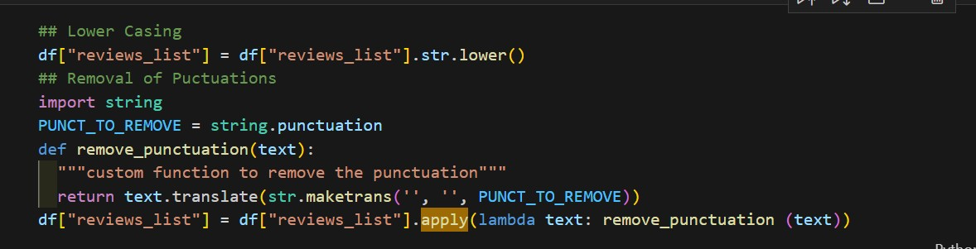

Data Preprocessing Code Screenshots
Loading Data | 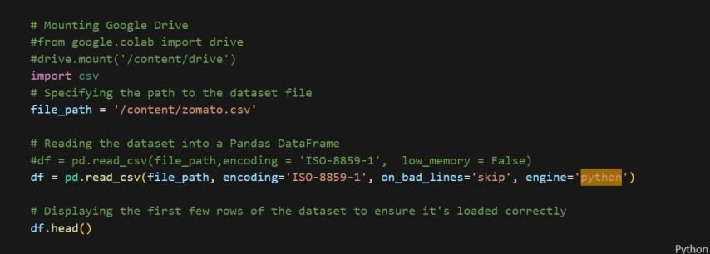
Resizing | Not applicable
Normalization | 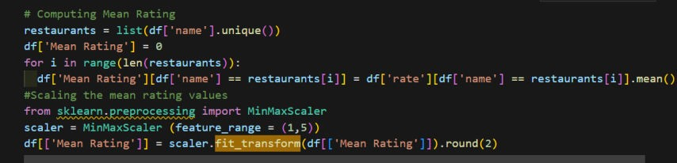
Data Augmentation | Not applicable
Denoising
Edge Detection | Not applicable
Color Space Conversion | Not applicable
Image Cropping | Not applicable
Batch Normalization | Not applicable

4.Model Development Phase

Model Selection Report

Model | Description
Content-Based Filtering | Content-based filtering recommends restaurants by comparing user preferences (e.g., cuisine type, price range, dietary restrictions) with restaurant attributes. It focuses on similarities between items and the user's profile without relying on other users’ data. This method is effective for users with unique tastes but may struggle with limited user profiles (cold start).
Collaborative Filtering | Collaborative filtering leverages the preferences of similar users to make recommendations. It uses historical ratings and reviews to identify patterns. This model is effective in discovering new items but can suffer from sparsity and cold start problems if data is limited.
Hybrid Recommendatio n Model | This combines content-based and collaborative filtering to overcome the limitations of each method. By integrating both user preference data and behavior of similar users, hybrid models improve recommendation accuracy, diversity, and scalability. It is particularly useful in scenarios with large, sparse datasets like restaurant recommendations.
Matrix Factorization | Matrix factorization techniques decompose the user-item interaction matrix into latent features, capturing underlying patterns in user preferences. Singular Value Decomposition (SVD) is a common approach. It is computationally efficient and works well for large datasets but requires enough ratings.
Deep Learning (Neural Networks) | Neural networks can be used to build recommendation systems by learning complex, non-linear relationships between users and restaurants from rich feature sets including reviews, preferences, and metadata. While powerful, they require large datasets and are computationally intensive.

Conclusion:

Model Selected
Hybrid Recommenda tion Model | The hybrid model was selected because it addresses the limitations of both content- based and collaborative filtering approaches. It effectively handles the cold start and sparsity issues by integrating multiple data sources such as user profiles, restaurant attributes, and behavioral data. This results in more personalized, diverse, and accurate recommendations, making it highly suitable for a restaurant recommendation system with varying user preferences and data availability.

Initial Model Training Code, Model Validation and Evaluation
Report

Initial Model Training Code, Model Validation and Evaluation Report Initial Model Training Code (5 marks):

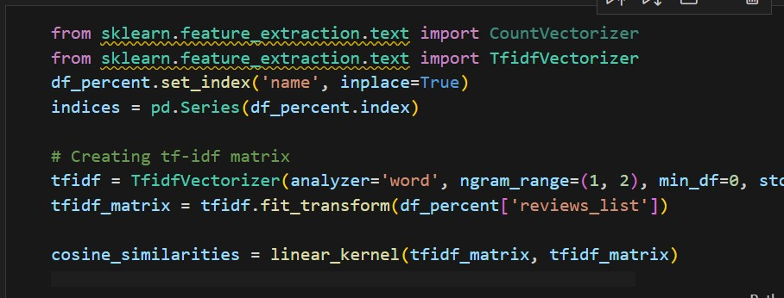
Model Validation and Evaluation Report (5 marks):

Model | Summary | Training and Validation Performance Metrics
Model 1 | Content-based Recommendation | Training Metrics -None (unsupervised, no explicit training phase)  Validation Metrics - None (recommendations are inspected manually)

2 Model Optimization and Tuning Phase

2.1 Tunning Documentation

Hyperparameter Tuning

Model | Tuned Hyperparameters
Model 1: Content-Based Filtering | - Similarity Metric: Cosine similarity was used as the primary metric to compute similarity between restaurants based on features like cuisines, rating, and cost.  - Top N Recommendations: The number of top similar restaurants returned was tested with values like 5, 10, and 15.  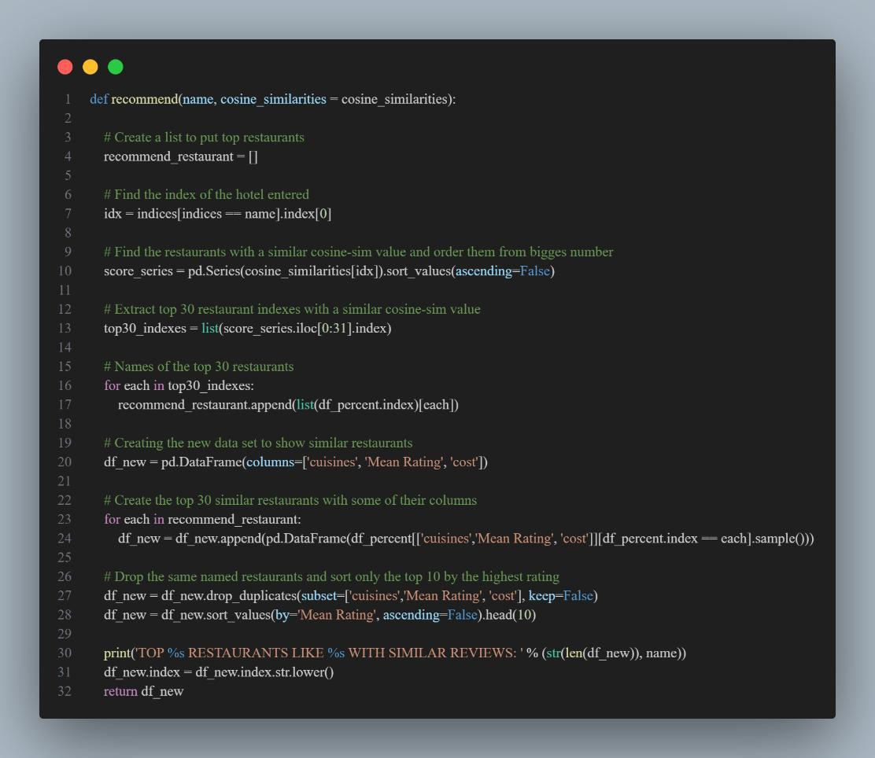

Model 2: Collaborative Filtering
Algorithm: SVD (Singular Value Decomposition) from the Surprise library.
Learning Rate: Tuned values such as 0.005, 0.01, and 0.02 were tested.
Regularization: Parameters such as 0.02, 0.05 were tried to avoid overfitting.
Number of Epochs: Adjusted between 20 and 100 epochs.

Final Model Selection Justification

Final Model Selection Justification:

Final Model | Reasoning
Model 1: Content- Based Filtering | Selected due to its simplicity and good performance without requiring detailed user history. It gave interpretable and relevant results using restaurant features like cuisines, ratings, and cost.

3 Results

3.1 Output Screenshots

Home Page:
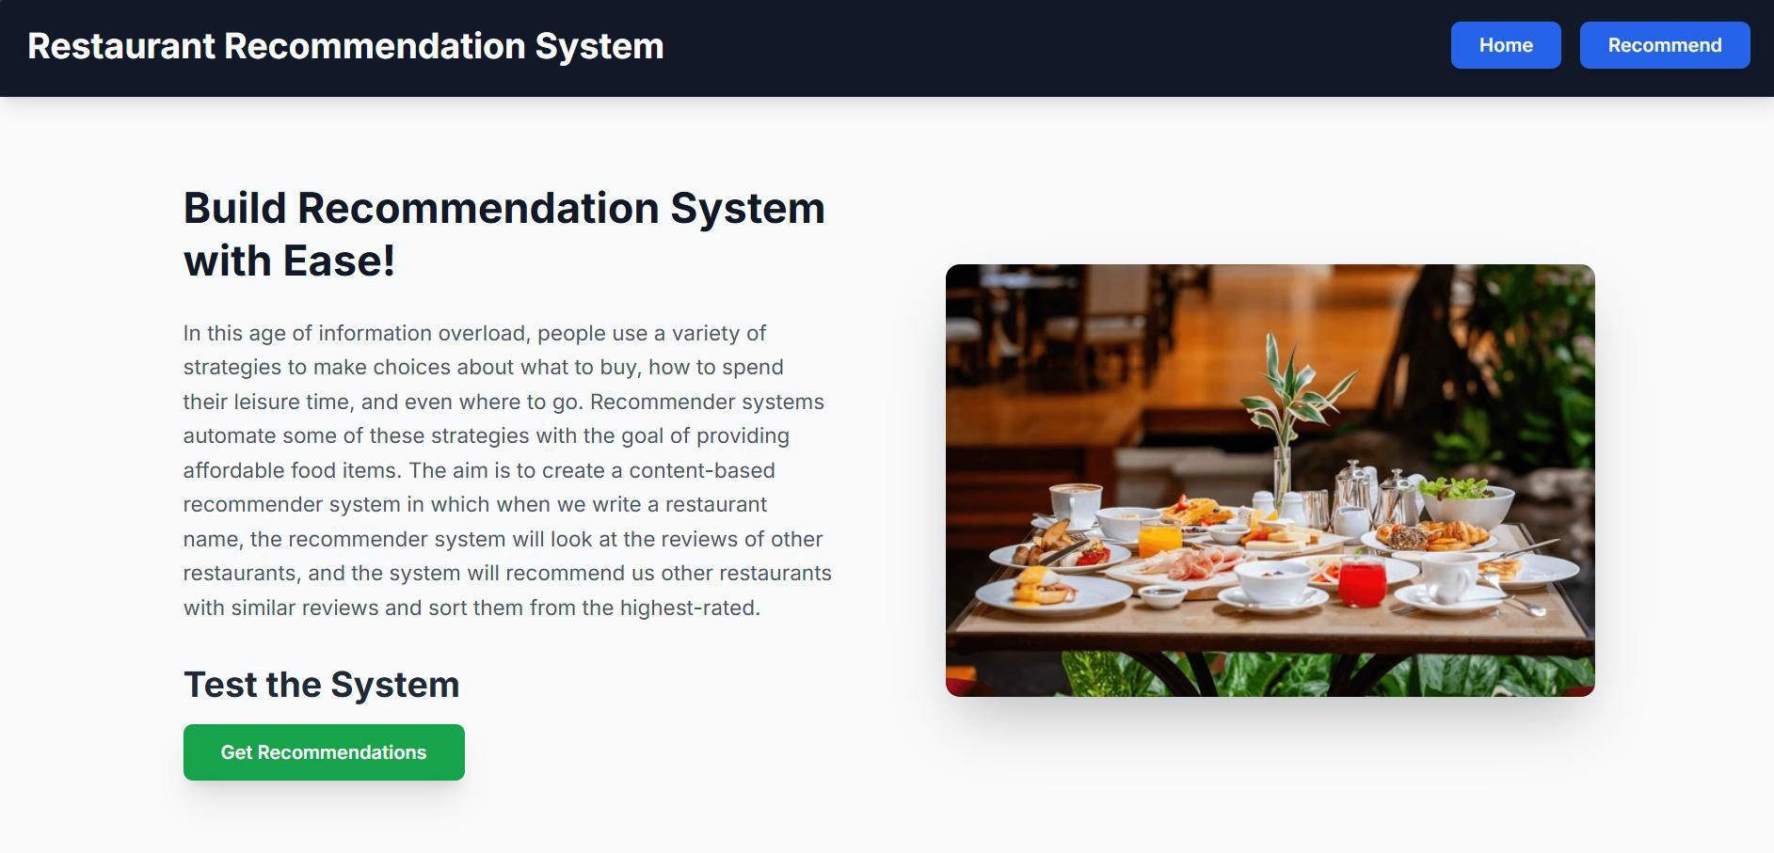

Input Page:
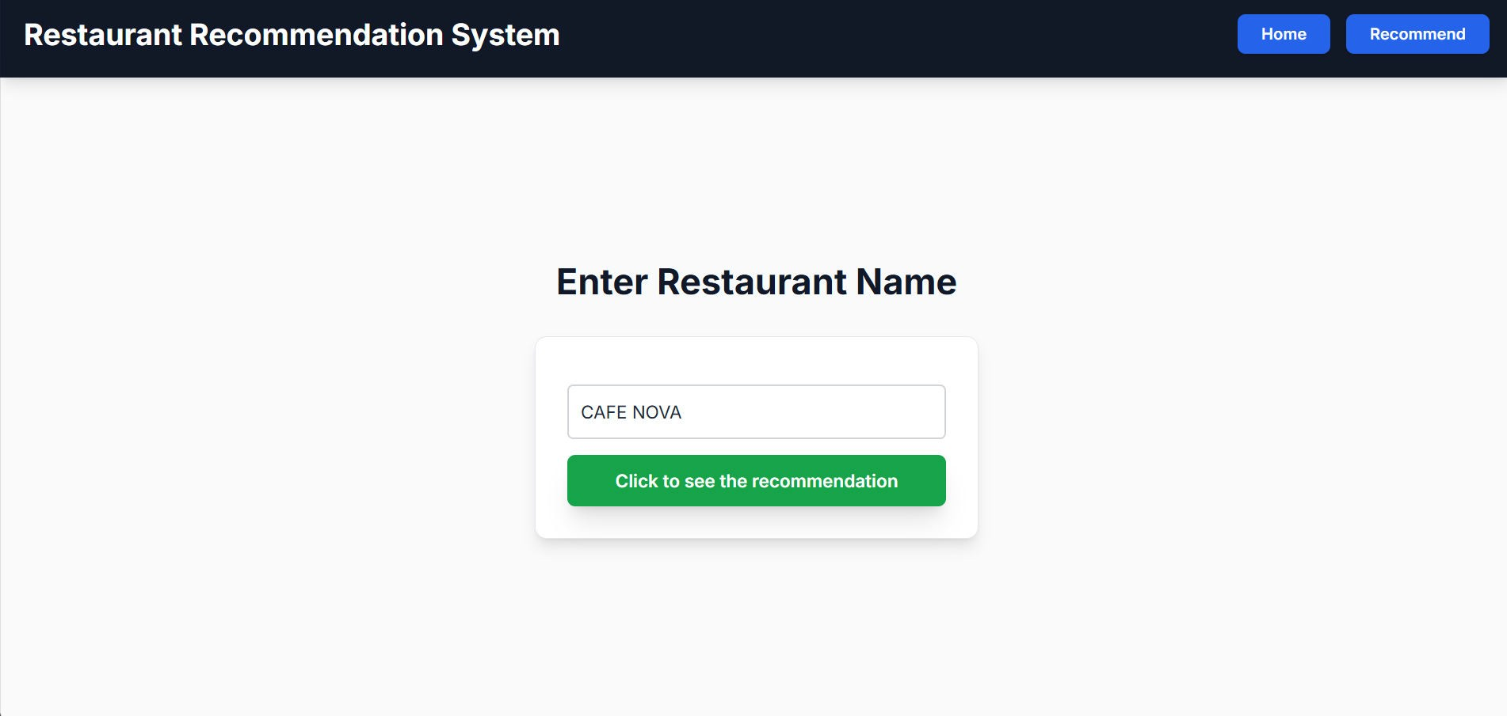

Output:
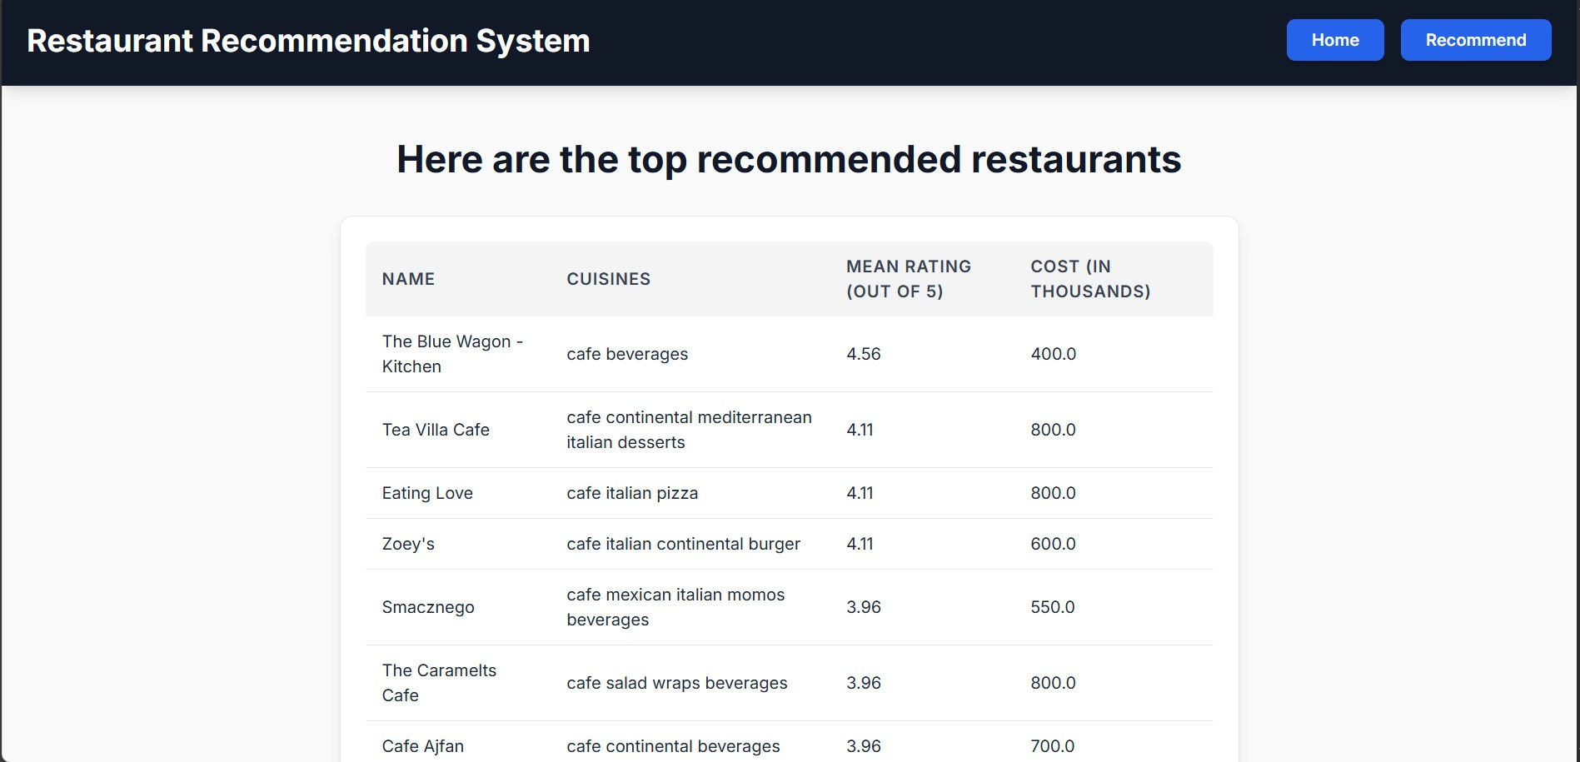

4 Advantages & Disadvantages

Advantages:
    - Personalized User Experience: Tailors dining options based on user preferences, dietary needs, and previous behaviour.
    - Time-saving: Reduces the effort needed to search and choose a restaurant.
    - Improved Discoverability: Helps smaller or new restaurants gain visibility through recommendations.
    - Data-Driven Decisions: Uses user ratings, reviews, and location data to make informed suggestions.
    - Enhanced Customer Satisfaction: Users are more likely to enjoy their meals when recommendations align with their preferences

Disadvantages:
    - Privacy Concerns: Collecting and analyzing user data (location, preferences) can raise privacy issues.
    - Bias in Recommendations: Algorithms might favor sponsored listings or high-traffic restaurants, reducing diversity.
    - Dependence on User Data: Inaccurate or limited data can lead to poor recommendations.
    - Over-Personalization: Users might be confined to similar choices, missing out on new or diverse dining experiences.
    - Scalability Issues: Maintaining system accuracy and performance can become challenging as the user base grows.

5 Conclusion
A restaurant recommendation system is a powerful tool for enhancing the dining experience by delivering tailored suggestions based on user behavior, preferences, and location. While it offers significant benefits such as convenience, personalization, and efficient decision-making, it also presents challenges including data privacy, system bias, and the risk of user data dependency. Future advancements in AI, real-time analytics, and user interface technologies promise to make such systems more intelligent, inclusive, and immersive. With careful implementation and ethical considerations, this system can transform how users explore and enjoy culinary option

6 Future Scope

      - Integration with AR/VR: In the future, users could take virtual tours of restaurants or view their ambiance in AR before booking.
      - Voice Assistant Compatibility: Integration with Siri, Alexa, or Google Assistant to provide hands-free restaurant suggestions.
      - Enhanced Personalization: Use deep learning and behavioral analytics to refine suggestions based on dietary restrictions, allergies, and eating habits.
      - Real-time Data Utilization: Incorporating real-time factors like wait times, special offers, and crowd density for more dynamic recommendations.
      - Multilingual Support: Expanding the system to support various languages to cater to a global audience.
      - Social Media Integration: Use of social media trends and check-ins to improve recommendation relevance.
      - Sustainability Preferences: Factoring in eco-conscious dining choices (e.g., locally sourced, plant-based, or low-waste restaurants).

7 Appendix

Source Code

[ https://github.com/adityabhole165/DS-Restaurant-recommendation-System/tree/main/Flask ]

Project Video Demo Link :

Video Demo Link:[https://drive.google.com/file/d/1UuniZCFLYgeJ1piQjoKXxgibjhgC e_link]

Qn/view?usp=driv

